Project Title : Cinema seat booking system

1.Abstract
Abstract
The Cinema Seat Booking System is a simple Java project.
The main purpose of this project is to book cinema seats easily.
The user can enter their name and select a movie.
The system shows the available seats for booking.
The user can choose the required seats.
The system checks whether the selected seats are available.
If a seat is already booked, it cannot be selected again.
The system calculates the ticket price based on the seats selected.
It then displays the total amount to be paid.
After booking, the system displays the booking details.
This project helps to reduce manual work in ticket booking.
It also helps to keep track of booked and available seats.
The project is developed using the Java programming language.
It uses basic concepts like variables and data types.
It also uses arrays, if-else statements, loops, and methods.
The Scanner class is used to take input from the user.
This project helps us understand Java through a real-life example.
It also improves our problem-solving and programming skills.
The system is simple and easy to use.
Overall, it provides an easy way to book cinema seats.

2.Advantages and Disadvantages
Advantages
- Easy and simple to use.
- Saves time in booking cinema tickets.
- Shows the available and booked seats.
- Prevents double booking of the same seat.
- Automatically calculates the total ticket price.
- Reduces manual work and errors.
- Keeps booking details organized.
- Provides quick booking confirmation.
- Helps users select their preferred seats.
- Helps students understand Java concepts through a real-life project.

Disadvantages
- The system has limited features.
- It does not support online payment.
- It is mainly suitable for small-scale use.

Implementation Details
- The project is developed using the Java programming language.
- The Scanner class is used to take input from the user.
- An array is used to store and manage the cinema seats.
- If-else statements are used to check seat availability.
- Loops are used to display and process the seats.
- Methods are used to perform different booking operations.
- The system calculates the total ticket price based on the number of seats selected.
- Finally, the system displays the booking details and total amount.

Java code:
import java.util.Scanner;

public class project {

static Scanner sc = new Scanner(System.in);
static boolean[] seats = new boolean[10];

static void displaySeats() {
System.out.println("\n--- Seat Status ---");

for (int i = 0; i < seats.length; i++) {
if (seats[i]) {
System.out.println("Seat " + (i + 1) + " - Booked");
} else {
System.out.println("Seat " + (i + 1) + " - Available");
}
}
}

static void bookSeat() {
System.out.print("\nEnter your name: ");
String name = sc.nextLine();

System.out.print("Enter movie name: ");
String movie = sc.nextLine();

displaySeats();

System.out.print("\nEnter seat number to book: ");
int seatNumber = sc.nextInt();

if (seatNumber < 1 || seatNumber > 10) {
System.out.println("Invalid seat number!");
}
else if (seats[seatNumber - 1]) {
System.out.println("Sorry, this seat is already booked!");
}
else {
seats[seatNumber - 1] = true;

int ticketPrice = 200;

System.out.println("\n--- Booking Successful ---");
System.out.println("Customer Name : " + name);
System.out.println("Movie Name : " + movie);
System.out.println("Seat Number : " + seatNumber);
System.out.println("Ticket Price : ₹" + ticketPrice);
System.out.println("Status : Confirmed");
}
}

public static void main(String[] args) {

int choice;

do {
System.out.println("\n==============================");
System.out.println(" CINEMA SEAT BOOKING SYSTEM");
System.out.println("==============================");
System.out.println("1. Display Seats");
System.out.println("2. Book a Seat");
System.out.println("3. Exit");
System.out.print("Enter your choice: ");

choice = sc.nextInt();
sc.nextLine();

switch (choice) {
case 1:
displaySeats();
break;

case 2:
bookSeat();
break;

case 3:
System.out.println("Thank you for using the system!");
break;

default:
System.out.println("Invalid choice!");
}

} while (choice != 3);

sc.close();
}
}

Output screenshots
1.Main menu
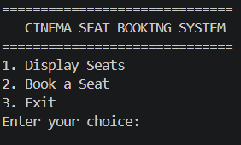

2. Display Seats
If no seats are booked:
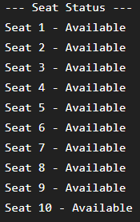

3.Successful Booking
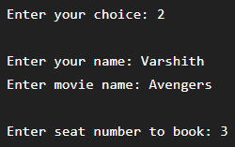

Output:
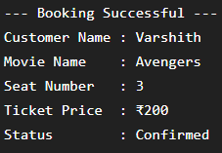

- Display Seats After Booking

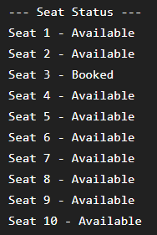

- Unsuccessful Booking — Already Booked
If you try to book Seat 3 again

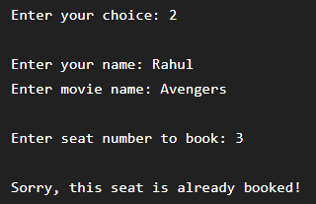

- Invalid Seat Number — Too High

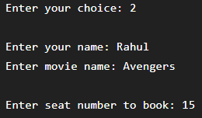

Output:

Conclusion
The Cinema Seat Booking System is a simple Java project that makes cinema seat booking easy and organized. It allows users to check available seats, select a seat, and view their booking details. The system also prevents booking a seat that is already booked. Through this project, we learned how to use Java concepts like arrays, loops, if-else statements, switch-case, methods, and Scanner. Overall, this project helped us understand how Java can be used to create a simple real-life application.

